Game idea generation – my main idea for a game consists of a first person shooter that makes you kill enemies that come in waves, these waves have increased difficulty and get progressively longer, as the game progresses you develop and illness and have to go around the map curing it, after you cure yourself you can chose to leave and save yourself or continue the mission, if you leave the game ends and you have the option to restart on a harder difficulty or on a different map, but if you chose to stay a counter will appear on the top of your screen, which when you kill a certain amount of enemies (with increasing amounts) you will unlock a waypoint and It will show you where the first part of the cure to the rest of the world is, once you have obtained all 3 parts to this cure you will need to go to the highest point of the map and spread it across the whole map which will cure 99% of people, after this you will get another option to leave the game and start again or to stay and finish the remaining zombies with some added help this time.

Location
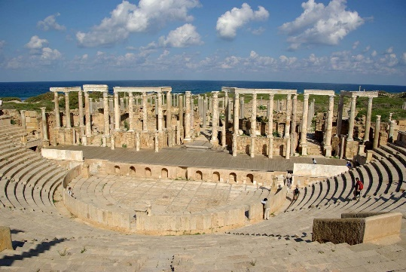
Leptis magna
Leptis magna is located in the northwestern part of Africa and the main attraction is the theatre in the centre which is a main tourist attraction, I chose this place as it has the most architectural structure and it looks the best for my theme, as it has the best spawn points that I could find in man made architecture. I believe that because of where it is located and the main structure of the building it will be rather easy to build and create in unreal.
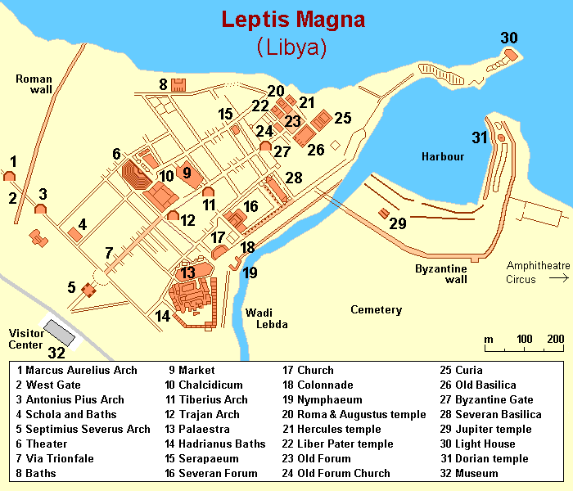

Zombies – in my game I want the zombies to come from under the map and chase the player they should have minimum health and this being increased as the rounds go up.

PEGI ratings
PEGI 3 – for a game to receive the PEGI 3 rating the game should not contain sounds or pictures that would frighten a young child, you may have very small hints of violence(in a comical context) and no swearing or any form of gambling should be allowed in the game.

PEGI 7 – for a game to receive the PEGI 7 rating they are allowed to scare young children very slightly and forms of violence is allowed but it should be turned down to match the PEGI 7 rating this content may not be graphic or realistic, there is still no swearing or gambling in these games.

PEGI 12 – for the game to receive a PEGI 12 rating they may show very slightly more graphic content towards fantasy characters however this may not be realistic and it may not be to any human like characters, sexual inuendo and sexual posturing is allowed in these game however any swearing is to be kept “mild” and gambling is still not allowed.

PEGI 16 – for a game to reach a PEGI 16 this must be when a game reaches violence towards humans and displays blood at a minor level. however, sexual activity in these games is allowed to how it should be presented in real life the use of swearing is allowed a lot more in these games and can be more “extreme” you are allowed to use tobacco, alcohol and or illegal drugs. They also may be present in the game. Gambling is still not to be present or allowed in the game at all.

PEGI 18 – For a game to reach the PEGI 18 this is when violence has reached an extreme point and displays motiveless killing or violence towards defenceless characters. A PEGI 18 rated game may also include the glamorisation of drugs and or gambling. You may also have sexual activity that can be completely shown. Gambling is allowed at whatever degree you may chose in these games

For my game I will be using a PEGI rating of 7 as my game doesn’t contain any majorly violent actions, this means that the game cannot be a PEGI 3 as my game has some factors that will increase the PEGI rating, but not enough for it to go above a 12, like the zombies aspect of the game and how it is classed as a “fantasy character” therefore the rating doesn’t need to go above PEGI 12.

Game Genres
Roleplay games
The definition of a roleplaying game is a game where players may assume the role of a character in a fictional game, players will take the role of trying to act out their best version of the character making their own dialogue as they go
Sandbox games
The definition of a sandbox game is a game where players can make whatever they want whenever they want to make it, this is where they have no predetermined goals or objectives the word being from a literal sandbox where people can make whatever they want with the sand.
Puzzle games
The definition of a puzzle game is a game where you have to solve a problem to win/beat a level or the game itself, which tests the users knowledge, they are meant to use skills to take apart the puzzle and make something out of it.
Action games
The definition of an action game is a game which holds physical challenge, this type of game genre has many sub genres inside of it due to it being a very broad term. Most of these games focus on your core skills, like hand eye coordination and you reaction time. They also contain loads of combat and movement.
Action-adventure games
The definition of an action-adventure game is a video game hybrid genre which has multiple of the same assets as a action game, and has the same elements as a puzzle game too. This mix of action adventure pulls people into the game and makes action more interesting for more people.
Adventure games
The definition of an adventure game is that it is a puzzle solving game, these games can contain some elements of combat but it would be kept to a minimum as it is mostly for puzzle solving, a good example of this would be in the game limbo as it contains some elements of attacking, like in the earlier stages of the game where you defeat a mini boss.
Simulation games
The definition of a simulation game is a game where it takes some aspects of real life, this being the buildings and cities, there is strictly no defined goals for the main character and it is an open and free game.
Strategy games
The definition of a strategy game is a game which emphasizes thinking and planning over action to achieve the win condition most games have elements of strategy games inside of them however they prioritize the combat or other aspects of the game, which makes it a combination of the two.
Sports games
The definition of a sports game is a game where you compete in physical activities between two teams or individuals these games often have rules and objectives to achieve the win condition.
Idle games
The definition of idle games is a game where the player doesn’t have to input with their keyboard or anything to continue progression on the game these games include clicker type games where the player has very little inputs.

Shooter games
The definition of a shooter game is a game where you use weapons or guns to fight the enemies in the game a lot of games are “FPS” games. These games are games that you need to be in first person for, first person being where you can see through the eyes of the main character e.g. Call of Duty, this game is a good example of the first-person genre as you play as a character with a weapon in first person however you can also play third person shooters where you are looking at your character shoot, a good example of this would be Fortnite, as the camera angle of Fortnite is behind the character looking down on them when you shoot your weapon. There can be different genres of shooter games, like the hero shooter genre which has games like overwatch and apex, both good examples of games that use hero type characters/abilities for defeating enemies. Another type of shooter games is tactical shooters; this includes games like rainbow six siege where you have to use more strategy and thinking to play the game well.

Conclusion
In conclusion to my research I have gained a lot of knowledge about the place I am basing my main design from and it showed me a lot of things that I didn’t know before, this helps my project as it gives me a clear understanding of why certain things were built and lets me add things to my game which will increase its possibilities for lore and other additions. Other things that I gained from my research was my look into the different game genres, this helps me as it gave me a clear view of what I wanted my game to be rated and how I think it should be rated, this is useful as before I did not know anything about what the certain PEGI ratings meant, which helped me a ton with my game. I did end up choosing PEGI 7 for my game as I think it would fit it best and I believe that it should be the rating for the game, this helped me as it told me my boundaries at the very beginning so I knew what I would be capable of doing and what I couldn’t without breaking the boundaries of the game and ruining it. Lastly, for my research into genres I believe that this helped me because it showed me all of the different genres and gave me a different view on what I actually wanted to choose, some of the genres that I looked into were things that I had not heard of before and they gave me a different view on the project than what I had on it before, in the end I ended up choosing the shooter genre, specifically the FPS(first person shooter) type of the genre, this helped my project as I knew how I wanted the camera to be like so I could set it early on into the development of the game. In conclusion my research was a big help to my project and it definitely helped with the production and the making of the game.

